**DBMS ASSIGNMENT 8**

**CLASS: TE B**

**ROLL NO: 322008**

**Problem Statement:** Database Trigger (All Types: Row level and Statement level triggers, Before and After Triggers). Write a database trigger on Library table. The System should keep track of the records that are being updated or deleted. The old value of updated or deleted records should be added in Library_Audit table.

**Screenshots:**

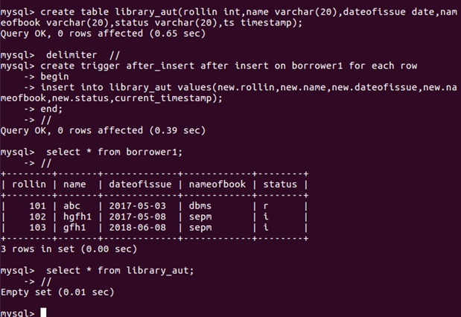

**Queries:**

Create table library_aut(rollin iny, name, varchar(20), dateofissue date, nameofbook varchar(20), status varchar(20), ts timestrap);

Create trigger after_insert after insert on borrower1 for each row

Begin

Insert into library_aut values(new.rollin, new.name, new.dateofissue, new.nameofbook, new.status current.timestamp);

End;

Select * from borrower1;

Select * from library_aut;

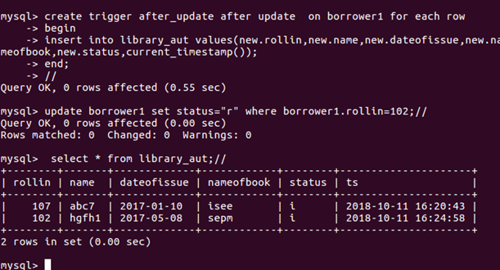

**Queries:**

Create trigger after_update after update on borrower1 for each row

Begin

Insert into library_aut values(new.rollin, new.name, new.dateofissue, new.nameofbook, new.status current.timestamp);

End;

Update borrower1 set status = “r” where borrower1.rollin = 102;

Select * from library_aut;

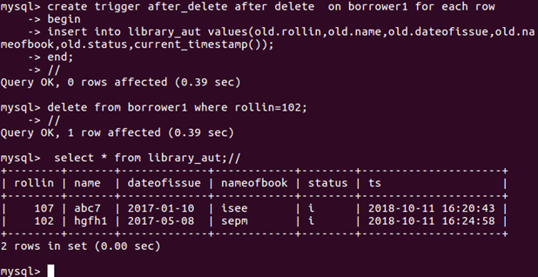

**Queries:**

Create trigger after_delete after delete on borrower1 for each row

Begin

Insert into library_aut values(new.rollin, new.name, new.dateofissue, new.nameofbook, new.status current.timestamp);

End;

Delete from borrower1 where rollin = 102;

Select * from library_aut;

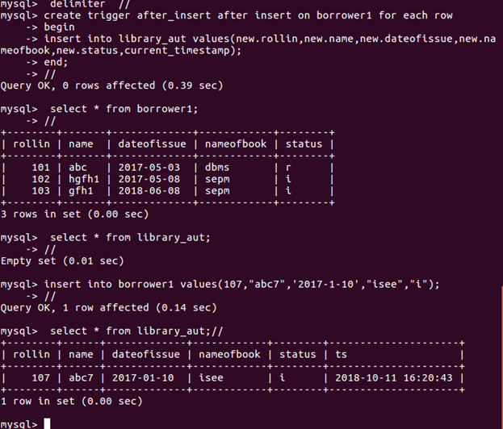

**Queries:**

Create trigger after_insert after insert on borrower1 for each row

Begin

Insert into library_aut values(new.rollin, new.name, new.dateofissue, new.nameofbook, new.status current.timestamp);

End;

Select * from borrower1;

Select * from library_aut;

Insert into borrower1 values(107, “abc7”, ‘2017-1-10’,”isee”, “i”);

Select * from library_aut;

**Conclusion:** Database triggers were implemented successfully